Form
EpEx Feedback Form
Doc.Code: | GLX_HRM_FRM_EpEx FeedbackForm
Version # | 2.1 | Effective Date | 03/22/2021 | Email | galaxeindiahr@galaxe.com
 |  | Contact | HR Team

Program: Sounding Board | Program Date: 25-Aug-22 @ 2:00 PM | Location: Zoom

Thank you for joining one of our EpEx Programs. We request you to share your valuable feedback about this program.
Note: Rating is on a scale of 1-5, 1- Below Average, 2-Average, 3-Good, 4-Very Good & 5-Excellent
If any item has the rating of less than 3, kindly suggest the improvement that you would like to see.
- How was your overall experience of the above program?
  - Below Average 2. Average 3. Good 4. Very Good 5. Excellent
- Was the above activity done properly by the concerned HR Person?
  - Strongly Disagree 2. Disagree 3. Neutral 4. Agree 5. Strongly Agree

- Do you think this particular activity is useful to our Employees?

  - Strongly Disagree 2. Disagree 3. Neutral 4. Agree 5. Strongly Agree

- Are you motivated after this particular activity?

  - Strongly Disagree 2. Disagree 3. Neutral 4. Agree 5. Strongly Agree

- Do you want us to continue doing this activity?
  - Strongly Disagree 2. Disagree 3. Neutral 4. Agree 5. Strongly Agree

- Any other suggestions/inputs you have to share:

Overall session was good.

Name of the Employee: NAGENDRA B S
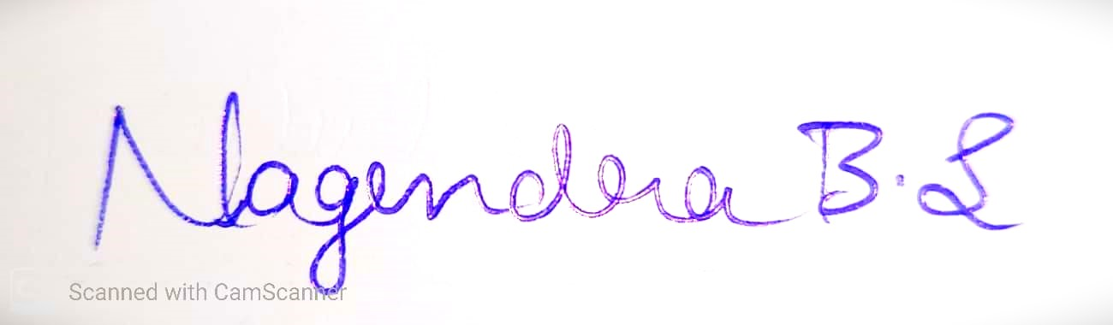
Account : 3980
Signature of the Employee

